Ajay Gokul P M
DevOps Assessment

1. What does WSL stand for in the context of Windows?
Answer: c. Windows Subsystem for Linux

2. What is the primary goal of continuous integration (CI) in DevOps?
Answer: b. Frequent integration of code changes

3. In the Linux command line, what does the cd command do?
Answer: b. Change the working directory

4. Which of the following is not a Linux distribution?
Answer: c. Docker

5. What is Docker primarily used for in DevOps and containerization?
Answer: c. Packaging and deploying applications in containers

6. What is the primary purpose of Azure DevOps?
Answer: b. Software development and delivery

7. Which components are part of Azure DevOps?
Answer: c. Azure Boards and Azure Pipelines

8. How does Azure DevOps support version control in software development?
Answer: b. It tracks changes in source code and manages versions.

9. In Linux, what is the primary role of the root user?
Answer: c. Administrative tasks with superuser privileges

10. In Azure DevOps, which component is used to define, build, test, and deploy applications?
Answer: c. Azure Pipelines

Lab 1: File and Directory Management
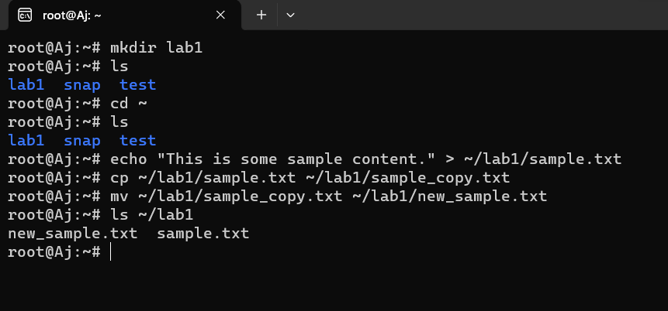

Lab 2: Permissions and Ownership

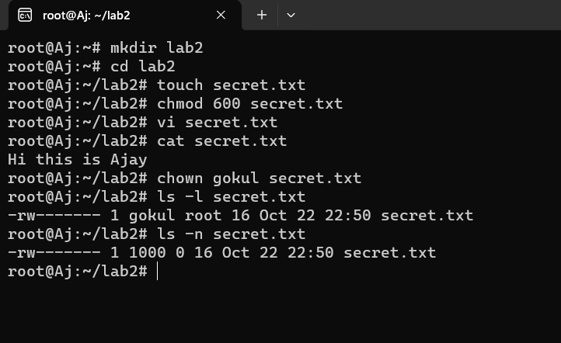

Lab 3: Text processing with CLI
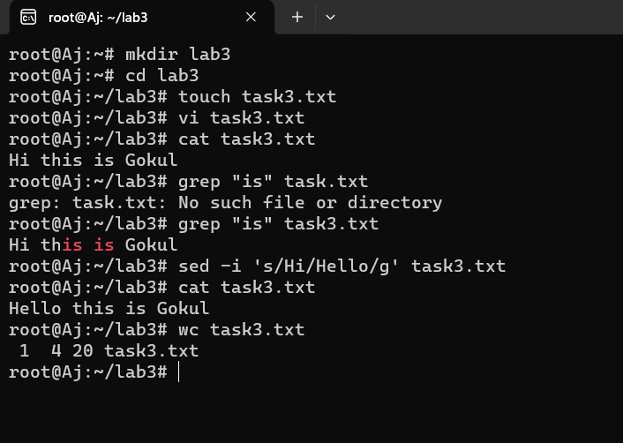

Lab 4: Creating a simple yaml file
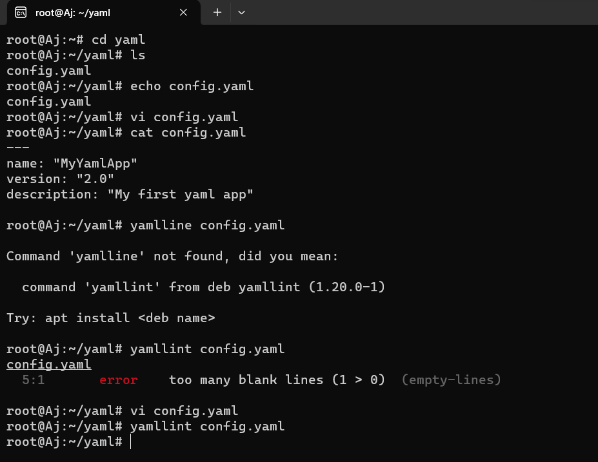

Lab 5: Working with lists in yaml

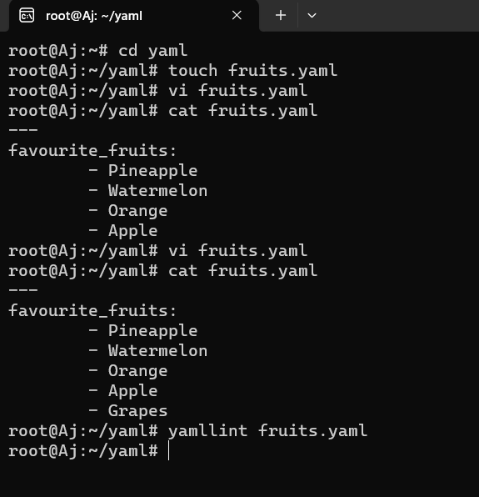

Lab 6: Nested Structures in yaml

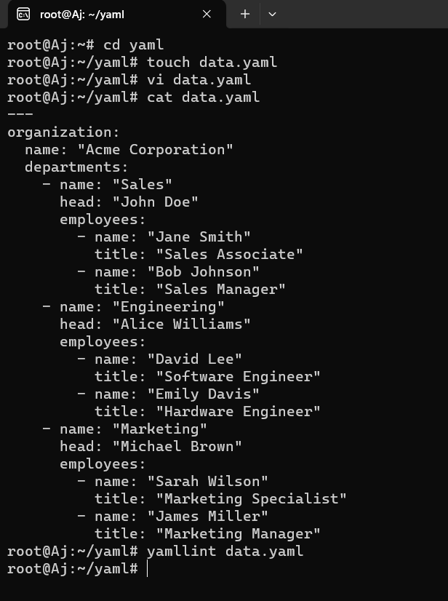

Lab 7: Create classic Azure CI pipeline for Angular application
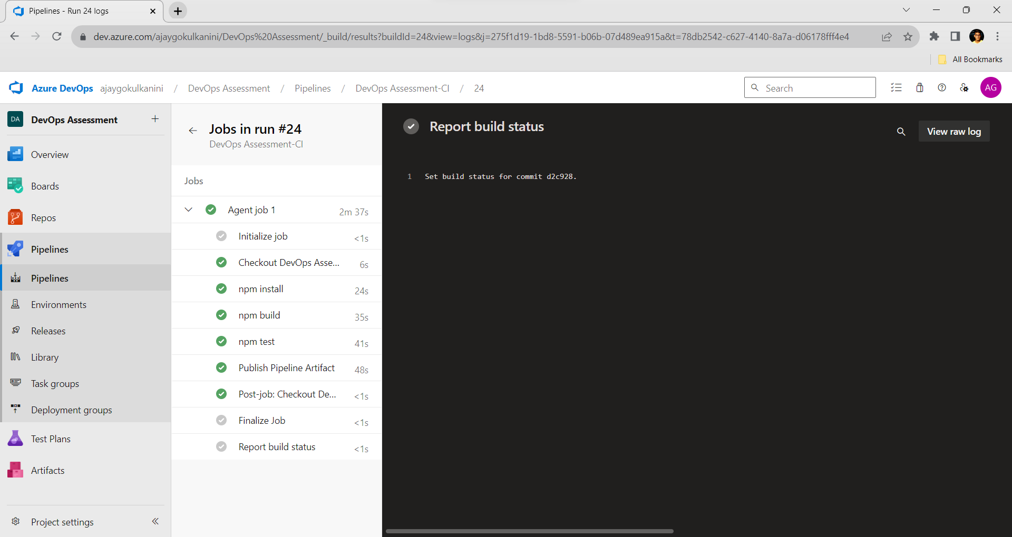

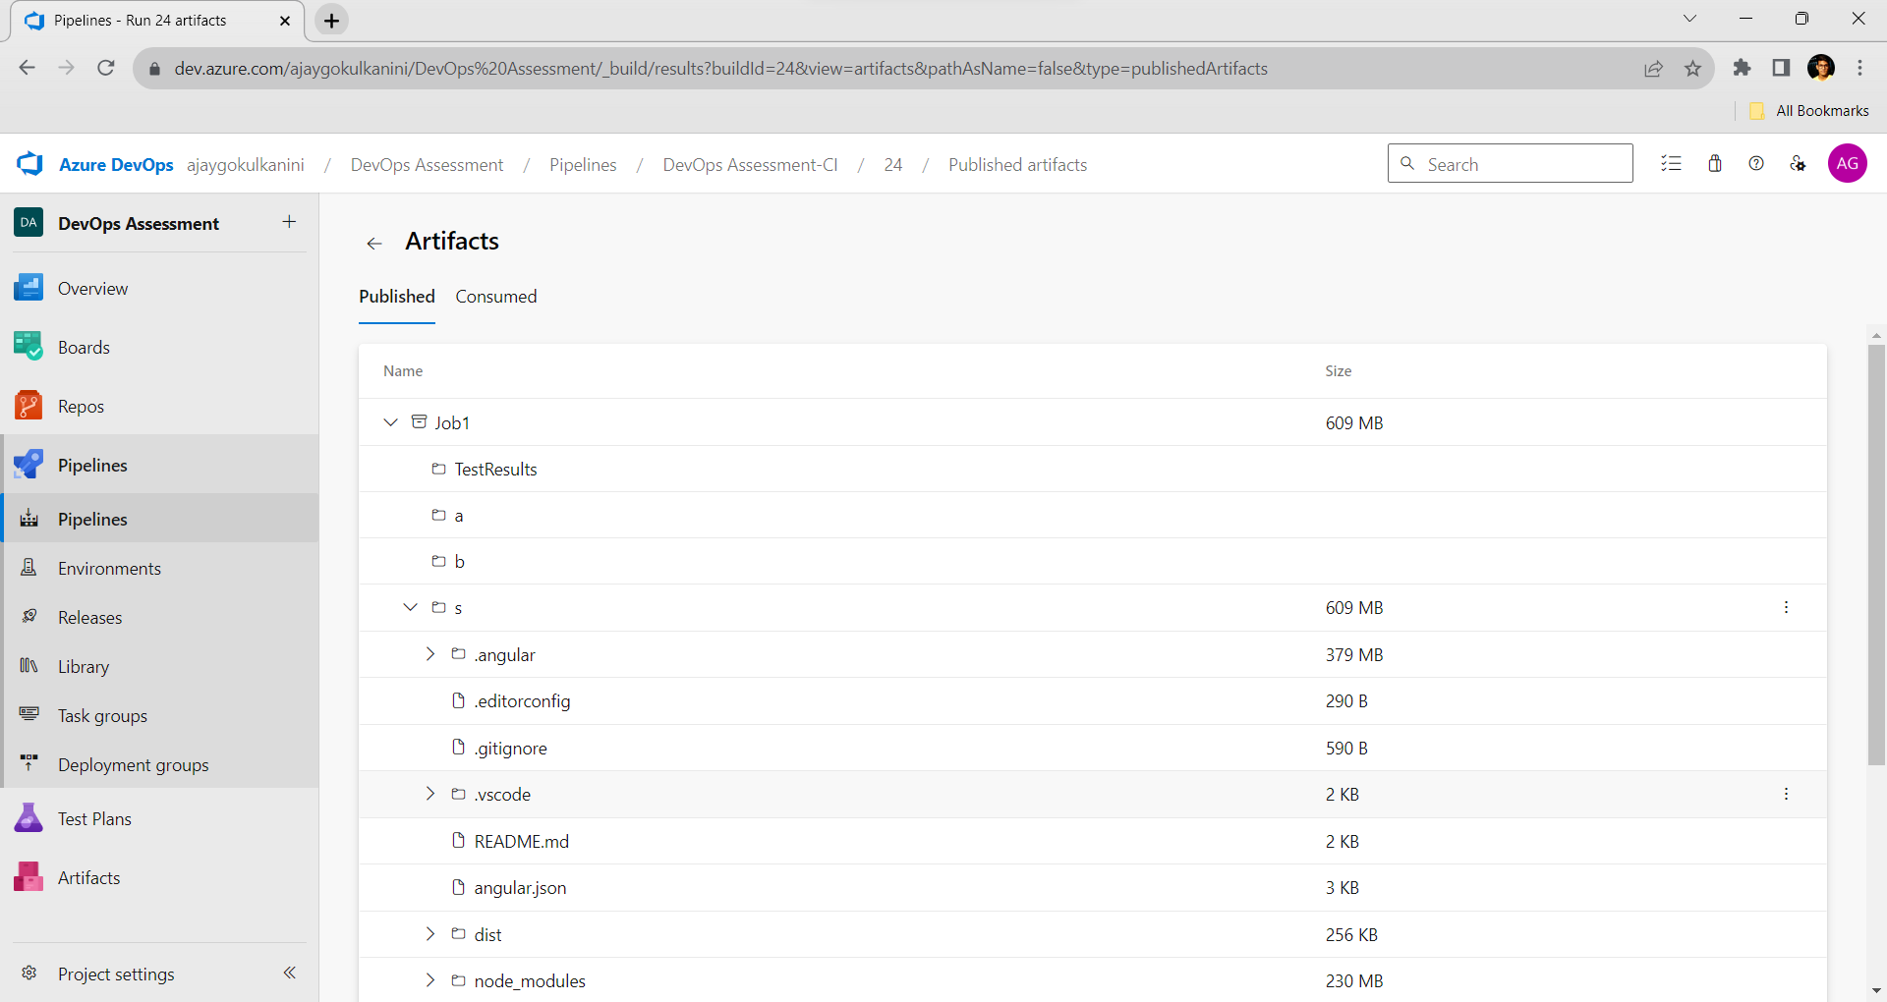

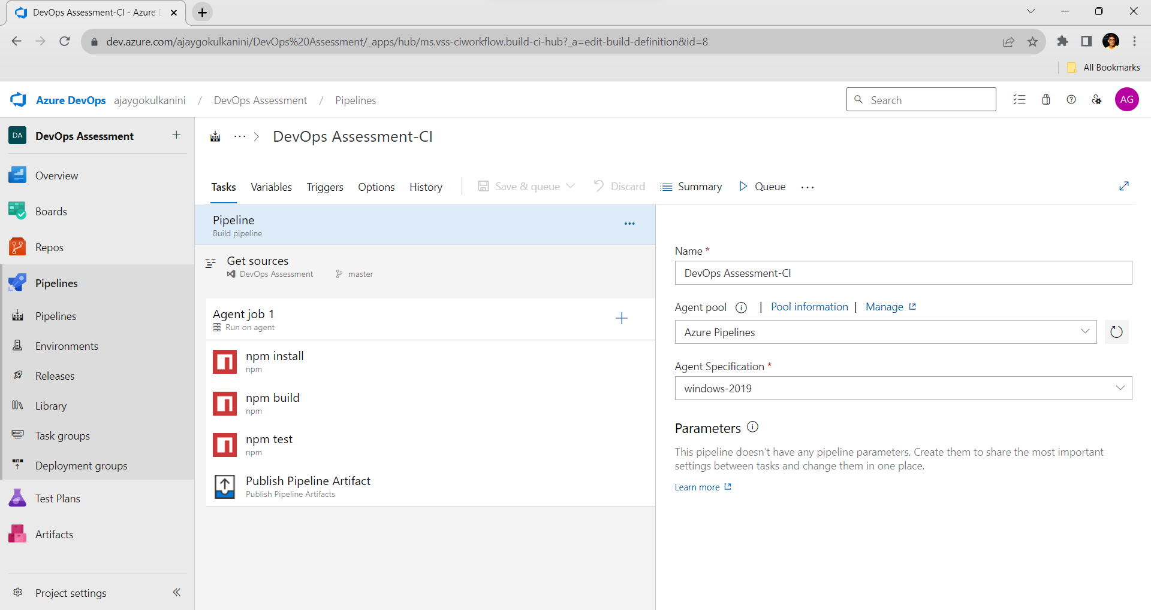

Lab 8: Create YAML Azure CI Pipeline for React Application

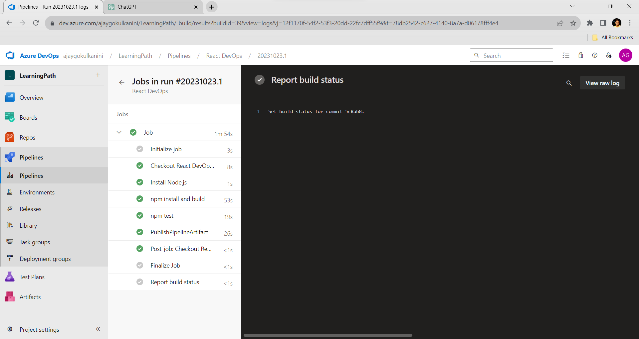

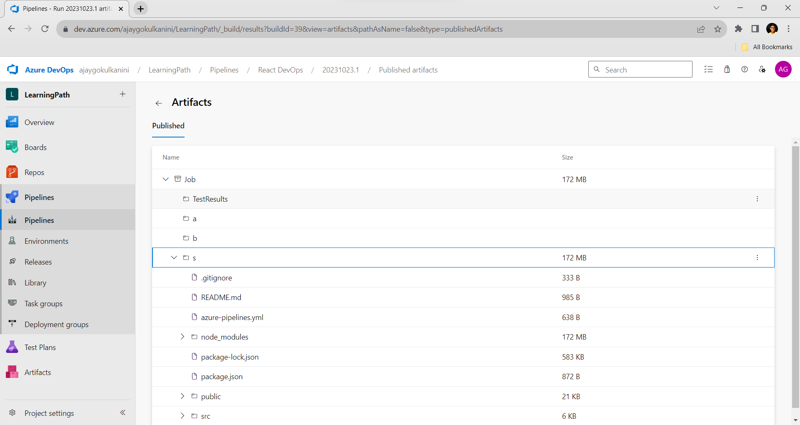

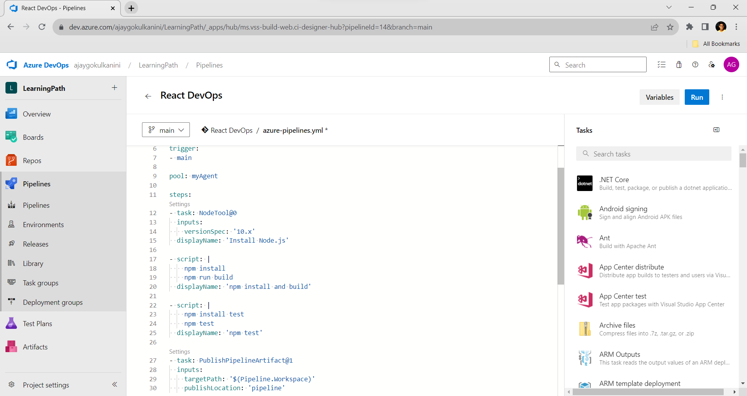

Lab 9: Create CI Pipeline for .NET Core Application with MS Unit Test

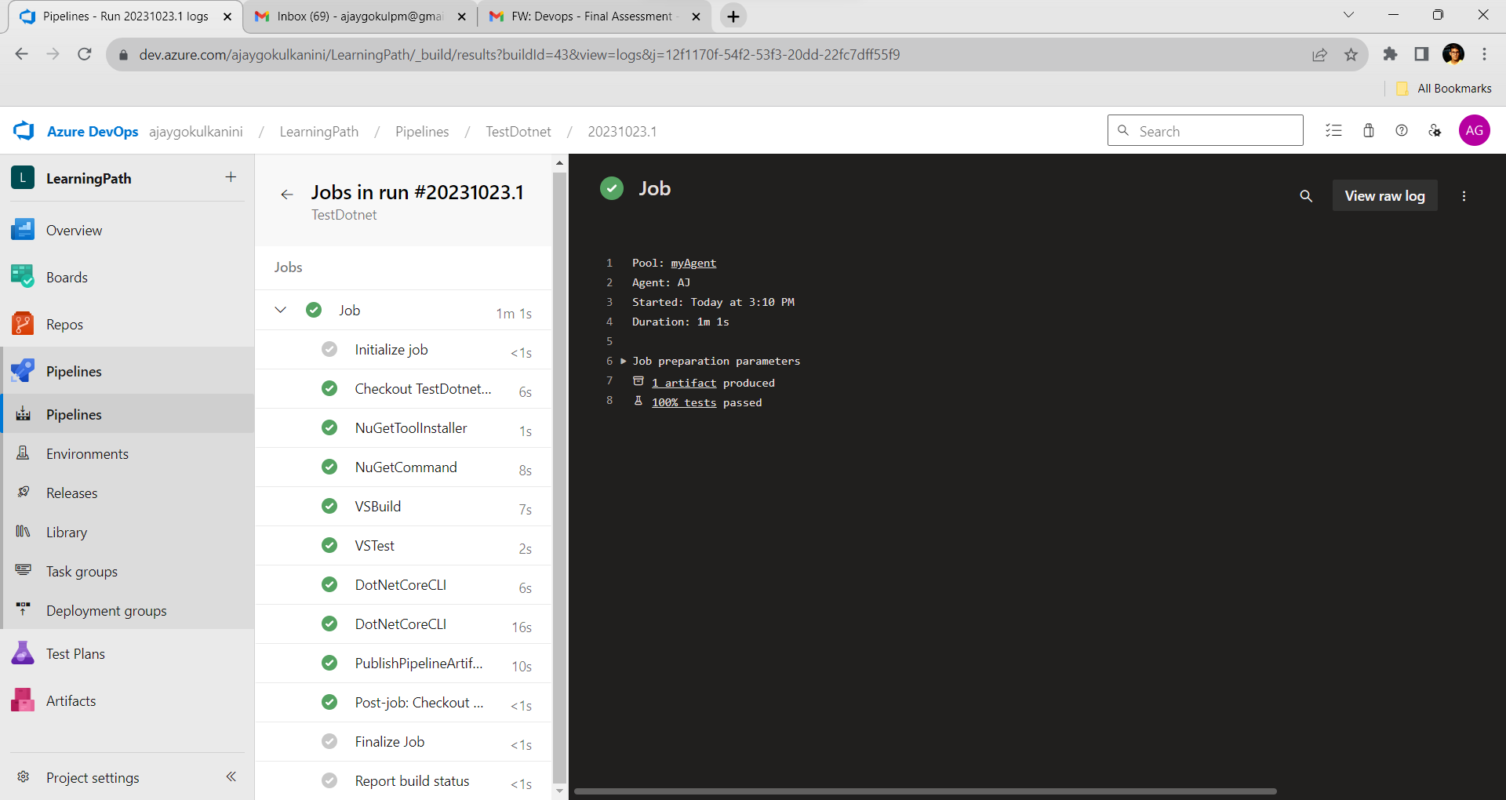

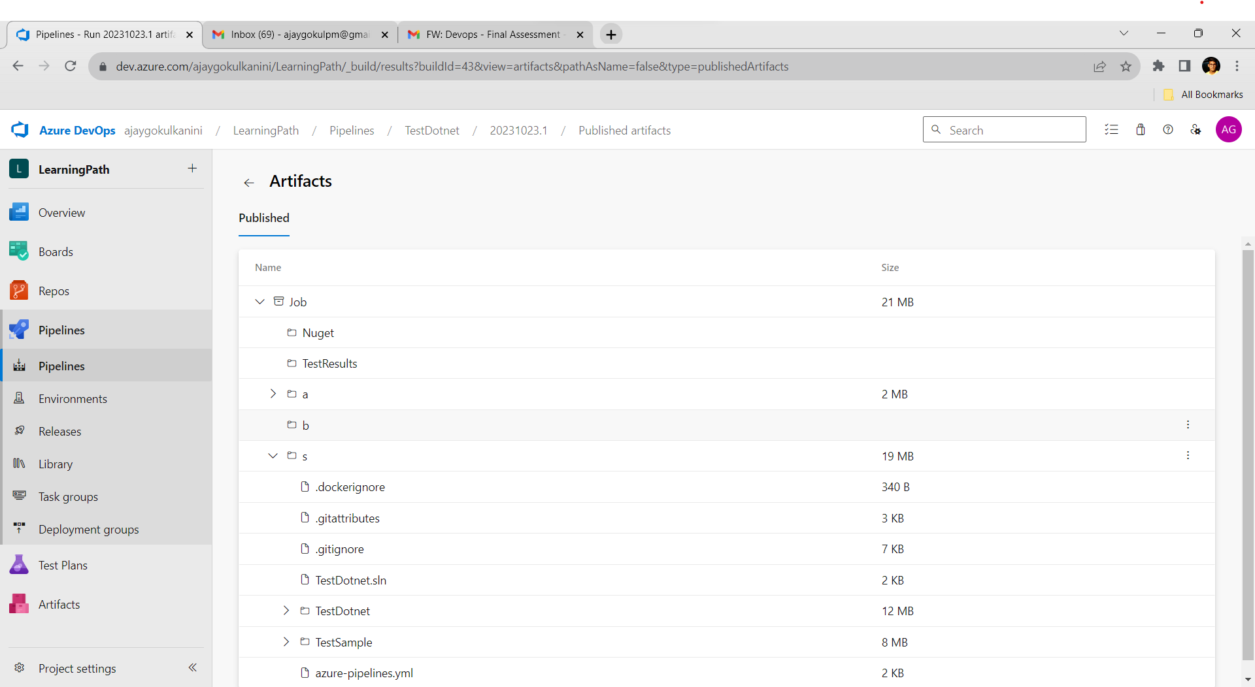

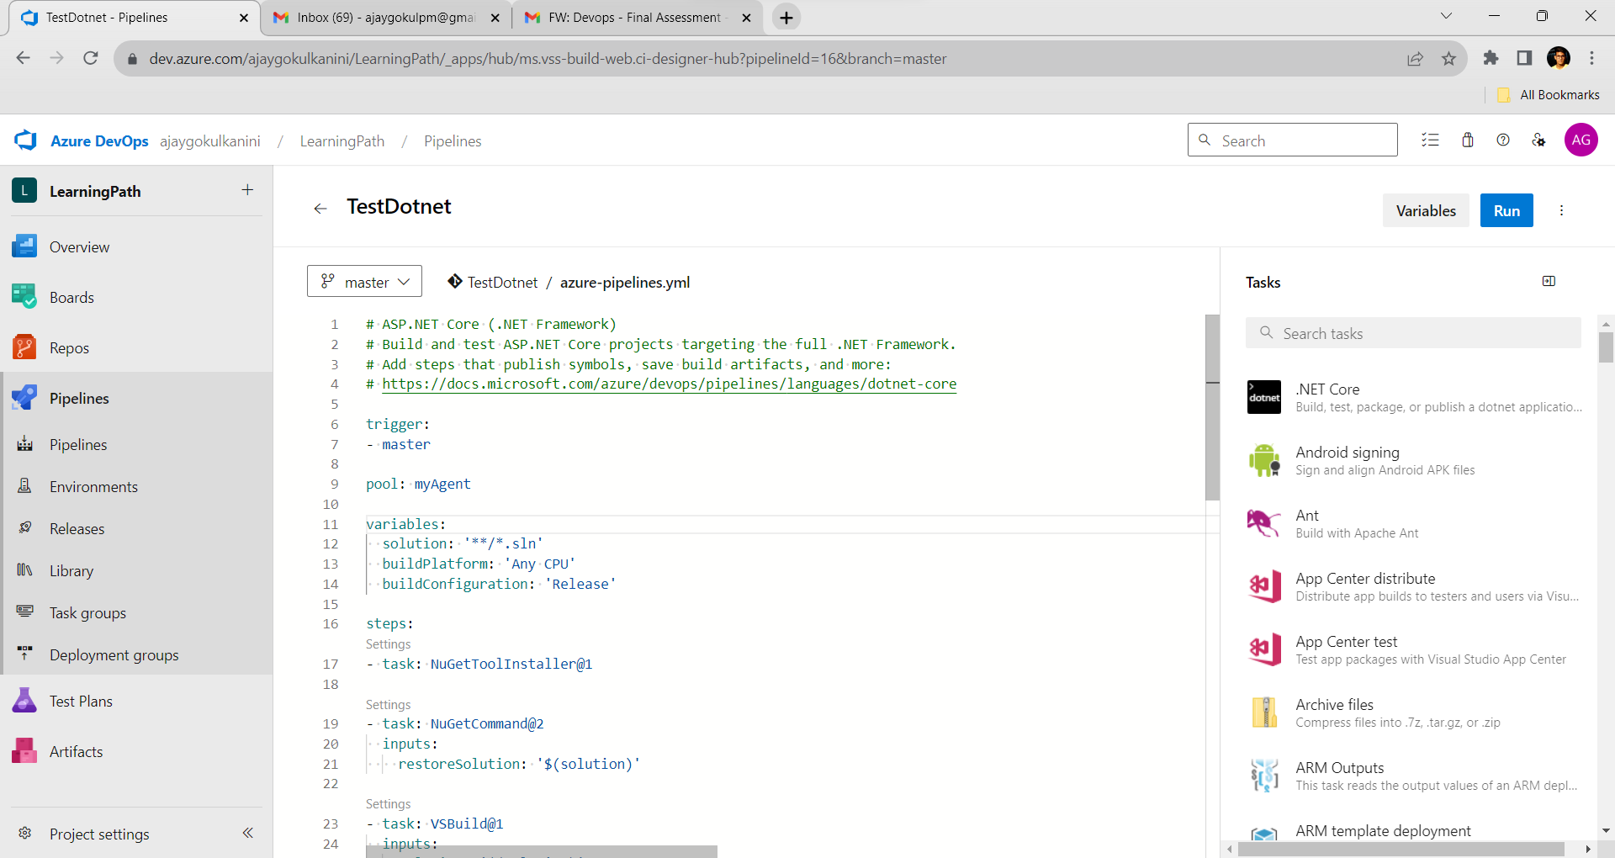

# ASP.NET Core (.NET Framework)
# Build and test ASP.NET Core projects targeting the full .NET Framework.
# Add steps that publish symbols, save build artifacts, and more:
# https://docs.microsoft.com/azure/devops/pipelines/languages/dotnet-core

trigger:
- master

pool: myAgent

variables:
solution: '**/*.sln'
buildPlatform: 'Any CPU'
buildConfiguration: 'Release'

steps:
- task: NuGetToolInstaller@1

- task: NuGetCommand@2
inputs:
restoreSolution: '$(solution)'

- task: VSBuild@1
inputs:
solution: '$(solution)'
msbuildArgs: '/p:DeployOnBuild=true /p:WebPublishMethod=Package /p:PackageAsSingleFile=true /p:SkipInvalidConfigurations=true /p:DesktopBuildPackageLocation="$(build.artifactStagingDirectory)\WebApp.zip" /p:DeployIisAppPath="Default Web Site"'
platform: '$(buildPlatform)'
configuration: '$(buildConfiguration)'

- task: VSTest@2
inputs:
platform: '$(buildPlatform)'
configuration: '$(buildConfiguration)'

- task: DotNetCoreCLI@2
inputs:
command: 'build'

- task: DotNetCoreCLI@2
inputs:
command: 'test'

- task: PublishPipelineArtifact@1
inputs:
targetPath: '$(Pipeline.Workspace)'
publishLocation: 'pipeline'

Lab 10: Creating a Docker Image for a .NET Core Web API and Running it in Rancher Desktop

